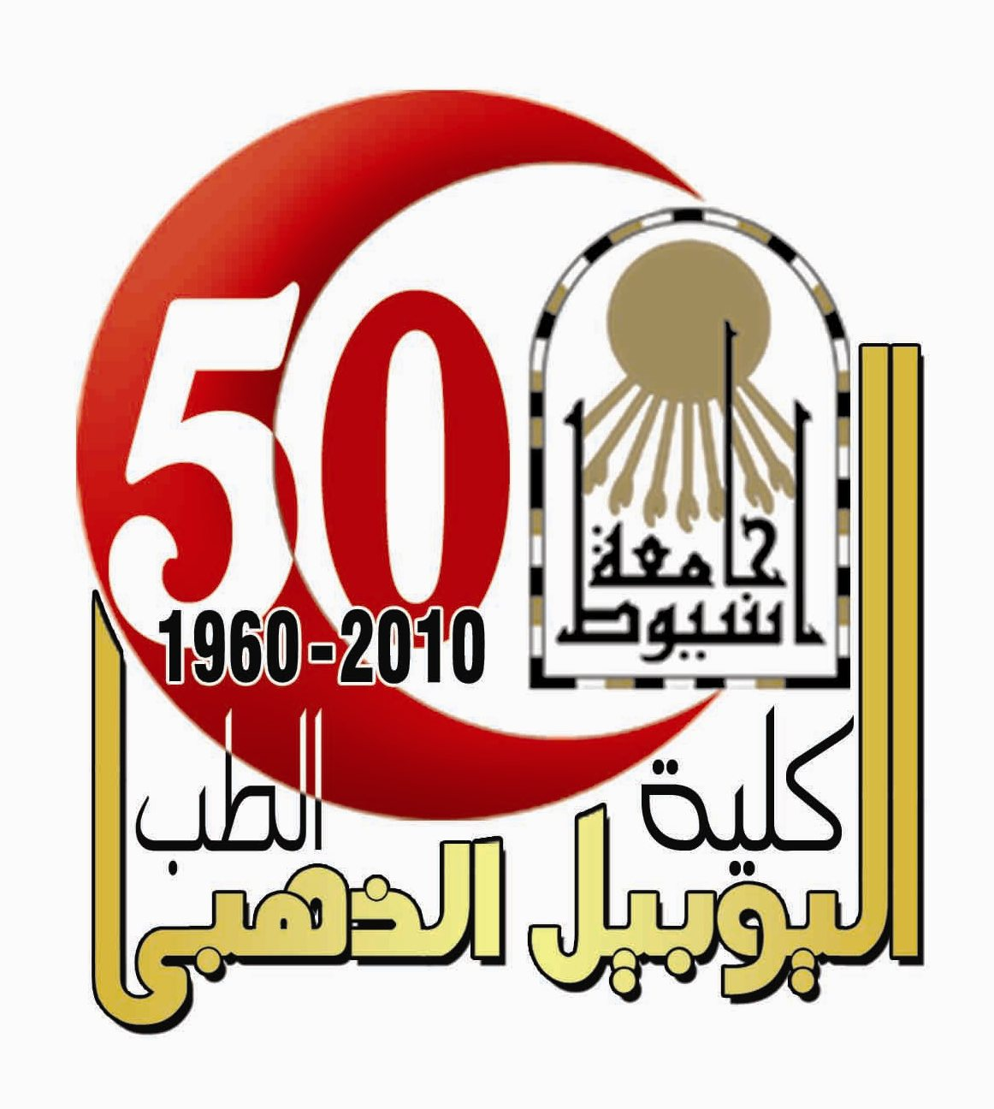
Culminated Vitae
Of Dr. Enas A. Hamed, MD
Professor of Physiology, Faculty of Medicine, Assiut University
Assiut, Egypt

PERSONALINFORMATIONS:
Title: Professor of Physiology, MD
Name: Enas Ahmed Hamed Omran.
Nationality: Egyptian.
Date and Place of Birth: 8th of March 1963, Bani Swiff, Egypt.
Address: Department of Physiology, Faculty of Medicine, Assiut University, Assiut, Egypt.
Telephone: +2 01064743592
Fax: +2 088 2333327
Email: eah3a2010@yahoo.com
Marital Status: Married and had two sons (22 and 19 years old).
QUALIFICATIONS:
1. Bachor of Medicine and surgery in 1986 {very good with honor}.
2. Master in Pediatric in 1990 “Respiratory distress syndrome in neonate” {very good}.
3. Master in Physiology in 1994 “Studies in baroreceptor reflexes in adult male hypertensive rabbits” {Excellent degree}
4. Ph.D. in Physiology in 1999 “Effect of atrial natruretic peptide on aldosterone secretion in bovine zona glomerulosa cells”. The practical part of the thesis was done in USA, health science center, University of Virginia (1997-1998).
5. Register for MD Pediatrics since septamber 2011 till now
EXPERIENCES:
- Professor of physiology, Faculty of Medicine, Assiut University, Egypt (2011 –till now)
- Associate professor of physiology, Faculty of Medicine, Assiut University, Egypt (2005 –2011)
- Lecturer of Physiology, Faculty of Medicine, Assiut University, Egypt (1999- 2005)
- Previous jobs and dates:
∗ Residence of pediatric in Pediatric Department, Assiut University Hospital (1st of March, 1987- 1990).
∗ Ademonstrator in Physiology Department (13th of June, 1991-1994)
∗ Assistant Lecturer of Physiology, Department of Physiology, Assiut University, Egypt (1994-1999).
- Post doctoral researches in respiratory, central nervous system, urinary system, hematology, reproductive and endocrine physiology.
- Major contributing author and editor for “Review in Central nervous system”, Faculty of medicine, Assiut University and books of physiology to pharmacy and dental students.
M.Sc and Ph.D. THESIS SUPERVISION:
- Supervising master degree student, the title of the thesis is “Cerebral dominance in healthy right and left handers”, Assiut University, Egypt, 1999-2001.
- Supervising master degree of Faculty of Science student, the title of the thesis is “The L-dopa agonist and antagonist on the mechanism of smooth muscle contraction of rats”, Assiut University, Egypt, 2001-2003
- Supervising the Ph.D. thesis, the title of the thesis is “Effect of L-dopa agonist and antagonist on kidney and cardiovascular functions of adult rabbits”, Assiut University, Egypt, 2004-2007.
- Supervising master degree student, the title of the thesis is “Physiological role of Endocannabinoid system” , Assiut University, Egypt, 2007-2009.
- Supervising Ph.D. thesis on “Role of Some Chemokines and Retinoic Acid in the Pathophysiology of Traumatic Induced Chronic Peripheral Neuropathic Pain in Rat Model”, Assiut University, Egypt, 2011 –till now.
- Supervising Ph.D. thesis on “The effect of vitamin E on lead- induced gonadal dysfunction in adult Wistar albino rat; Assiut University, Egypt, 2012 –2014.
FUNDED PROJECTS:
- Grant No. 426/008: TITLE “Serum concentration of soluble adhesion molecules as markers of endothelial damage in children with meningitis in Makkah Region” From King Abdulaziz University. 12/12/1429.
- Deanship of Scientific Research (DRS), King Abdulaziz University, Jeddah, under grant number (13-140-D1432): Title Relation between ghrelin secretion and increased gastric acidity in rat animal model of smokers.
TEACHING EXPERIENCES:
- Postgraduate teaching physiology to student of master degree of pediatrics.
- Undergraduate courses in central nervous system to 2nd year Medical collage students Assiut university (2 hours per week).
- Undergraduate courses in physiology of urinary system, hearing and metabolism to 2nd year Medical collage students Alazhar university (2 hours per week).
- Undergraduate courses in physiology of cardiovascular system, autonomic nervous system, renal physiology to student of 1st year, Faculty of Pharmacy, Assiut University (2 hours per week).
- Undergraduate lectures in physiology of autonomic nervous system, central nervous system, renal system, respiratory system and diagestive system for the 2nd year , Faculty of Pharmacy, Alazhar University (2 hours per week).
- Teaching practical physiology for 3rd grade clinical pharmacy students.
- Teaching pathophysiology for 5th grade clinical pharmacy students (2 hours per week).
- Teaching experience for 2nd and 3rd years medical students, Pharmacy students, dental students, medical technology and nursing students, in Faculty of Medicine, King Abdel aziz University, Jeddah, Saudi Arabia (from 2003-2007).
TECHNIQUES MANAGEMED:
- Western blotting of the gel.
- Cell secretion Experiments.
- Basic Physiology and Biochemical techniques including quantitative Immuno- and spectroscopic assays.
- Radioimmunoassay techniques.
- Experiment animals research techniques.
SCHOOLARSHIPS:
- Msc scholarship, Faculty of Medicine, Assiut University (Pediatric Departments (1988-1990).
- Msc scholarship, faculty of Medicine, Assiut University (Physiology Departments (1991-1994).
- Visiting Research Ph.D. scholarship, faculty of Medicine, Assiut University to Health Science centers, University of Virginia, USA (1997-1998).
MEMBERSHIPS:
- Member of Egyptian Physiology Society, 1987.
REVIEWER TO THE FOLLOWING INTERNATIONAL JOUNALS:
- Acta Physilogica
- Chest Journal
- Clinical Nephrology
- Diabetes, Metabolic Syndrome and Obesity: Targets and Therapy
- European Journal of Clinical & Medical Oncology.
- Global Journal of Biochemistry.
- Journal of Diabetes and its Complications.
- Journal of Pediatric Neurology
- Journal of Pediatric Neuroradiology
- Saudi Medical Journal.
- International Journal of Clinical Toxicology.

CURRENT PROJECT AND INTEREST:
- Smoking and gastrointestinal hormones.
- Chemokines and peripheral neuropathy.
- Effect of lead on male and female reproductive system.
INTERNATIONAL PUBLISHED RESEARCHES:
1. Anwar Said, Eman M. Khedr, Enas Hamed, Jamal Basahi. Language cerebral dominance and handiness. European Journal of applied physiology 2002; 87(4-5): 469-473.
2. Enas A. Hamed, Ahmed Roshidy, Tarek El Motwally and Nagwa El Hosani. Dyslipidemia, oxidative stress and cardiac functions in end stage renal failure pediatric patients: effects of L-carnitine supplementation. Annals of Saudia Medicine 2003; 23 (5-6):270-277.
3. EA Hamed, ARMA Meki, AAA Gaafarand SA Hamed. Role of some vasoactive mediators in patients with erectile dysfunction: their relationship with angiotensin-converting enzyme and growth hormone. International Journal of Impotence Research 2003; 15: 418–425.
4. Enas A Hamed, America El Nowahi, Ashraf Z Mohamed and Azza Mahmoud EZZ El dean. Vasoactive mediators in patients with malignant and tuberculous pleural effusions. Respirology 2004; 9:81-86.
5. Sherifa A. Hamed, Enas A. Hamed, Mahmoud R. Kandil, Hala K. El-Shereef, Moustafa M. Abdellah, Hanan Omar. Serum thyroid hormone balance and lipid profile in patients with epilepsy. Epilepsy Research 2005; 66:173–183.
6. Enas A. Hamed , Soad J Mohamed, Abdel-Raheim M.A.Meki, Ehab Salam and Hazem Abdel Moti.. Urinary Tubular Enzymes Excretion in Children with Nephrolithiasis and Urolithiasis with Hydronephrosis. Aferican Journal of Urology 2006; 12(2):79-88.
7. Hamed S, Mohamed K, El-taher A, Hamed E and Omar H. The sexual and reproductive health in men with generalized epilepsy: a multidisciplinary evaluation. International Journal of Impotence Research 2006; 18: 287–295.
8. Sherifa A. Hameda, Enas A. Hamed, Ragaa Hamdy, Toshitaka Nabeshima. Vascular risk factors and oxidative stress as independent predictors of asymptomatic atherosclerosis in adult patients with epilepsy. Epilepsy research 2007; 74:183-192.
9. Hamed SA, Hamed EA, Shokry M, Omar H, Abdellah MM. The reproductive conditions and lipid profile in females with epilepsy. Acta Neurol Scand 2007; 115:12–22.
10. Enas A. Hamed, Eman A. Hamed, Sherifa A Hamed, Heba-Allah A.Gamal. Synovial fluid and serum levels of sE-selectin, IL-1β and TNF-α in rheumatoid arthritis patients. JKAU 2007; 14 (1):19-34.
11. Sherifa A. Hamed, Enas A. Hamed, Magda H. Farghaly, Khalid A. Ezam. Trace elements and flappy tremors in patients with liver cirrhosis: Is there a relationship? Saudi Medical Journal 2008; 29 (3):477-483.
12. Sherifa A. Hamed, Nadia M. Fida, Enas A. Hamed. States of serum leptin and insulin in children with epilepsy: Risk predictors of weight gain. European Journal of Pediatric Neurology 2009; 13:261-268.
13. Sherifa A. Hamed, Enas Ahmed Hamed, Mostafa M. Abdella. Septic encephalopathy: Relationship to serum and cerebrospinal fluid levels of adhesion molecules, lipid peroxides and S-100B protein. Pediatric Neuroscience 2009; 40:66-72.
14. Abdel-Raheim M.A.Meki, Enas A. Hamed, Khaled A. Ezam. Effect of Green Tea Extract and Vitamin C on Oxidant/Antioxidant Status of Rheumatoid Arthritis Rat Model. Indian Journal of Clinical Biochemistry 2009; 24(3): 280-287.
15. Sherifa A. Hamed, Enas A. Hamed, Madeha Zakari. S-100B protein and oxidative stress in children with bacterial meningitis. BMC Neurology 2009, 9:51-60 doi:10.1186/1471-2377-9-51
16. Soad M Jaber, Enas A Hamed, Sherifa A Hamed. Adhesion Molecules Profile in Children with Bacterial Meningitis and Sepsis. Journal of Pediatric Neurology 2009; 7:357–366.
17. Enas A. Hamed, Nagwa A Mohamed, Tarek H. EL-Metwally, Manal M. Kamal. Iron Chelation Therapy in Upper Egyptian Transfusion dependent Pediatric Homozygous b-Thalassemia Major. Impact on Serum L-Carnitine/Free Fatty Acids, Osteoprotegerin/ The Soluble Receptor Activator of Nuclear Factor-kB Ligand Systems, and Bone Mineral Density. J Pediatr Hematol Oncol 2010; 32:267–273.
18. Sherifa A. Hamed; Enas A. Hamed; Azza A. Mahmoud; Nagham N. Mahmoud. Vascular risk factors, endothelial function and carotid thickness in patients with migraine: relationship to atherosclerosis. Journal of Stroke and Cerebrovascular Diseases 2010; 19(2): 92-103.
19. Enas Ahmed Hamed, Nagla Taha Hanafi. Renal function in Pediatric Patients with β-Thalassemia Major: Relation to Chelation Therapy. Ital J Pediatr. 2010; 25;36(1):39.
20. Hamed EA, Meki AR, Abd El-Mottaleb NA. Protective effect of green tea on lead-induced oxidative damage in rat's blood and brain tissue homogenates. J Physiol Biochem. 2010; 66(2): 143-151 (DOI 10.1007/s13105-010-0019-5).
21. Enas A. Hamed, Nagla H Abu Faddan, Hebh A Adb Elhafeez, Douaa Sayed. Parathormone – 25(OH) -Vitamin D axis and Bone Status in Children and Adolescents with Type 1 Diabetes Mellitus. Pediatric diabetes 2011; 12:536-546 doi: 10.1111/j.1399-5448.2010.00739.x.
22. Enas Hamed, Madeha Zakary, Reffat Abdelal, Effat Abdel Moneim. Mechanism of vasculopathy in type 2 diabetes mellitus. Under puplication in J Physiol Biochem. 2011; 67(3):339-349. PMID: 21336648
23. Samer M. Zahran, Enas A. Hamed, Galia Z. A. Awean, Nagla M. Abdel-Hafez, Youssef S. Hassan. Pediatric burn and key regulatory cytokines: Impact of burn surface area and sepsis on the clinical outcomes. Pediatric Biochemistry 2011; 1(4): 279-288.
24. Enas A Hamed, Madeha M Zakary, Nagwa S Ahmed, Rania M Gamal.Circulating leptin and insulin in obese patients with and without type 2 diabetes mellitus: relation to ghrelin and oxidative stress. Diabetic research and clinical practice 2011; 94:434-441. PMID: 21924513.
25. Enas Ahmed Hamed, Sherifa Ahmed Hamed, Zienab A Alrefaie. Metabolic and hormonal changes in obese patients with and without diabetes mellitus. Accepted for publication in International Journal of Diabetes, 2011
26. Enas A. Hamed, Madeha M. Zakhary, Doaa W. Maximons.. Apoptosis, angiogenesis, inflammation and oxidative stress: basic interactions in patients with early and metastatic breast cancer. Cancer Res Clin Oncol (2012) 138:999–1009 DOI 10.1007/s00432-012-1176-4
27. Enas A Hamed, Madeha M Zakhary, Doaa W Maximous, Nagwa S Ahmed, Amany O Mohamed. Apoptotic versus angiogenic factors in gastric and colorectal cancers. Archives of Clinical and Experimental Surgery 2012; 1:71-84. DOI: 10.5455/aces.20120216121853
28. Enas A Hamed, Taghrid B El-Abaseri, Amany O Mohamed, Ahmed R Ahmed and Tarek H El-Metwally. Hypoxia and oxidative stress markers in pediatric patients undergoing hemodialysis: cross section study. BMC Nephrology 2012, 13:136 doi: 10.1186/1471-2369-13-136.
29. Soad Shaker Ali, Enas Ahmed Hamed, Nasra Naeim Ayuob, Ahmed ShakerAli, Mansour Ibrahem Suliman. Effects of Different Routes of Nicotine Administration on Gastric Morphology and Hormonal Secretion in Rats. Accepted and under publication in Experimental Physiology

LOCAL PUBLISHED RESEARCHES:
- Emtethal M. Moustafa, Salwa M Saleem, Manal M, Abdel Magid and Enas A. Hamed. Studies on baroreflex sensitivity in adult male rabbits.Bull Egypt Soc. Physiology Science 1995; 15:1.
- Ashraf Z Mohamed, Enas A, Hamed, Madeha M Zakary and Hamad El Shahat. The effect of passive cigarette smoking on the respiratory system among healthy wives of active smokers. Assiut Medical Journal 2001; 25:24.
3. Abdel El Reheim M A Mekki, Ashraf Z Mohamed, Enas A Hamed and Azza Mahmoud Ez Eldin. Induced sputum and plasma endothelin-1 level during acute attack of bronchial asthma: its relation to other proinflammatory mediators. Journal in biochemistry 2002; 20(2):1-22.
4. Enas A Hamed, Ashraf Z Mohamed, Azza Mahmoud Ez Eldin, Abdel Reheim M A Mekki and Wolfgang Domej. Concentrations of selected trace and bulk elements in serum and pleural fluid among patients with tuberculous and malignant pleural effusions. Egyptian Chest journal 2002;51(3):25-33.
5. Amira M. EL-Noweihi, Magda H. Farghaly and Enas A. Hamed. Serum Vascular endothelial growth factor, Soluble intercellular adhesion molecule-1 and nitric oxide levels in patients with acute myocardial infarction. The Egyptian Journal of biochemistry & Molecular Biology 2002; 22(2):1-22.
6. Abdel-Raheim M.A.Meki, Safwat A. Mohamed and Enas A Hamed. Alterations of maternal and umbilical cord leptin, insulin like growth factor–I, tumor necrosis factor-alpha and zinc levels in preeclampsia: Their relationships to newborn birth weight and severity of preeclampsia. The Egyptian Journal of biochemistry & Molecular Biology 2002; 20:37-54.
7. Mahmoud R Abdel Fadeil, Hatem Zedan, Enas A Hamed and Maher Abdel-Shakour. Endothelin-1 and nitric oxide in patients with organic and psychogenic erectile dysfunction. Egyptian Journal of Andrology and reproduction 2002; 16(2):87-100.
8. Amira M. El-Noweihi, Abdel-Raheim M.A.Meki, Enas A. Hamed and Ashraf Z. Mohamed. Matrix Metalloproteinase-2, Tissue Inhibitor of Metalloproteinase -2, Hyaluronan and Cathepsin D in Patients with Lung Cancers. The Egyptian Journal of Biochemistry & Molecular Biology 2002; 20:299-318.
9. Enas A. Hamed and Emtetham M Mahmoud. Baroreceptor sensitivity in pregnant rabbits. Egyptian Journal of Physiology 2003; 23(1):118-124.
10. Mohamed M Sayed, Ahmed R Ahmed, Nagwa A Mohamed, Tarek H El Metwally, Enas A Hamed. Serum antioxidant and Pro-oxidant trace Elements: Relationship with Oxidative Stress in Children with Chronic Renal Failure on Regular Hemodialysis. Alexandria Journal of Pediatrics 2006; 20(1):207-211.
11. Eman R. M. Hofny, Azza Ezz El-Deen, Heba Allah G. Rashed, Lubna M. Tag, Soheir Kamel Sayed, Ashraf E Hassaballa, Enas A. Hamed, Eman A. H. Omran, and Omar Herdan. Serum lipid, Apo E genotypes and tumor necrosis Factor Alpha in Psoriatic Arthritis Patients: in relation to Disease Activity. Egyptian Journal of Rheumatology 2007; 27(1):86-99.
12. Enas A Hamed, Ibtisam MH El Mileegy, Emtethal MH Moustafa, Nashwa A Abd El-Mottalib; Amal T Abou El- Ghait. Renal Actions of Dopamine D₃ Receptor Activation in Adult Male Rabbits. Society of Physiological Sciences and their applications 2008; 7(2): 513-540.
13. Enas A. Hamed, Emtethal M Moustafa, Nashwa A Abd El-Mottalib. Mechanisms of dopamine actions on cardiovascular system in adult male anesthetized Balady rabbits. Bulletin of Egyptian Society for Physiological Sciences 2010; 30 (2):125-148.
14. Ayman S. Amer, Hanan S. M. Farghaly, Ghada S. Mahmoud, and Enas A. Hamed. EFFECTS OF TRAMADOL VERSUS INDOMETHACIN ON GASTRIC MUCOSA IN RAT MODEL OF NOCICEPTION: A STRUCTURAL, IMMUNOHISTOCHEMICAL AND FUNCTIONAL STUDY. Assiut Med. J. 2013; 37 (2): 197- 214.
14. Enas A Hamed, Hayam G Sayyed, Amal T Abo-El gait, Heba M Galal.The effect of vitamin E on lead induced gonadal dysfunctions in adult Wistar Albino rats. Bull. Egypt. Soc. Physiol. Sci. 34 (2), 220-236
15. Minerva K. Fahmi, Enas A. Hamed, Madiha M. Mohammed Makhlouf, Hanan S. M. Farghaly, Asmaa F. Abdel Mola and Mohamed A. Balfas. Role of Some Chemokines in the Pathophysiology of Neuropathic Pain in Rats: Effect of Retinoic acid. Assiut Med. J. 2014; 38 (2): 1-24

CONFERENCES AND WORKSHOPS PARTICIPATIONS:
- Weekly Meetings of Departments of Pharmacology and Physiology in USA, health Science center, Charlottesville, Virginia.
- The Annual Scientific Meetings of Assiut Faculty of Medicine, Egypt, 1999.
- The Annual Scientific Meetings of Association of Chest Diseases, Cairo, Egypt, 1999.
- The Annual Scientific Meetings of Assiut Faculty of Medicine, Assiut, Egypt, 2000.
- The Annual Scientific Meetings of Association of Chest Diseases, Cairo, Egypt, 2000.
- The Annual Scientific Meetings of Assiut Faculty of Medicine, Assiut, Egypt, 2001.
- International conference of chest diseases, Assiut University, Assiut, Egypt, 2002.
- Conference of Pediatric, Assiut University, Assiut, Egypt, 2002.
- International Scientific conference of Alexandria thoracic Association in Palestine Helnan Hotel, Alexandria, Egypt 5-6th September 2002.
- “Strategic action of planning for the faculty of medicine”. Faculty of Medicine, King Abdulaziz University, Jeddah, Saudi Arabia; 15-16th December, 2003.
- SPSS. Faculty of Medicine, King Abdelaziz University, Jeddah, Saudi Arabia, 11-13th Septamber; 2004.
- Method of activation opanion document of princes Abdul Bin Abdelaziz about higher education. Faculty of Medicine, King Abdelaziz University, Jeddah, Saudi Arabia, 20th January to 1st February; 2005.
- Update course in modern respiratory medicine. Faculty of medicine, Assiut University, Assiut, Egypt, 6-8th sepatmber, 2005.
- Virus C and medical technology sed in its diagnosis and treatment. Faculty of Medicine, King Abdelaziz University, Jeddah, Saudi Arabia, 17th December; 2005.
- Advanced presentation skills workshop. Faculty of Medicine, King Abdelaziz University, Jeddah, Saudi Arabia, 14th May; 2006.
- Assess quality and dependance. Assiut University, Assiut, Egypt,15 -17th July, 2006.
- Usage of technology in teaching. Assiut University, Assiut, Egypt,15 -17th July, 2006.
- Are you student learning? Faculty of Medicine, King Abdelaziz University, Jeddah, Saudi Arabia, 19th Septamber; 2006.
- Councelling in an educational context instructors as counsellor and coach. Faculty of Medicine, King Abdelaziz University, Jeddah, Saudi Arabia, 9-13th December; 2006.
- System of credit hours. Assiut University, Assiut, Egypt,3 -5th Novemeber, 2007.
- System of examinations and evaluation of students. Assiut University, Assiut, Egypt,3 -5th Novemeber, 2007.
- Pubished research. Assiut University, Assiut, Egypt,10 -12th Novemeber, 2007.
- How to write compete research project. Assiut University, Assiut, Egypt,27 -29th October, 2007.
- 26th Annual conference of Assiut University,Faculty of Medicine, Assiut, Egypt, 8-11th March, 2008.
- Pediatic Rheumatology.Faculty of Medicine, Assiut University,Assiut, Egypt, 12-15th February, 2009.
- Advanced Hands on cource in modern pulmoary Medicine workshops (pulmonar function & sleep workshop). Faculty ofMedicine,Assiut Unversity, Assiut, Egypt 19-21th March, 2009.
- 27th Annual conference of Assiut University,Faculty of Medicine, Assiut, Egypt, 28-31th March, 2009.
- 28th Annual conference of Assiut University,Faculty of Medicine, Assiut, Egypt, 28-31th March, 2009.
- The 3rd International Conference of Saudi Association of Plastic surgery and Burns. Jeddah 3/5/2011-5/5/2011, Saudi Arabia.

REFERNCES:
Professor: Dr. Paula Q Barrette, Department of Pharmacology, Health Science center, University of Virginia, Charlottesville, Virginia, and USA. Email: pqb4b@virginia.edu; fax 804 982 3878
Professor Dr. Mahmoud Raffate, Department of Physiology, Faculty of Medicine, Assiut University, Egypt. Telephone: Work 011 20 88 411903, Home: 011 20 88 323553, Fax: 011 20 88332278, E-mail: mrafadeil@yahoo.com

